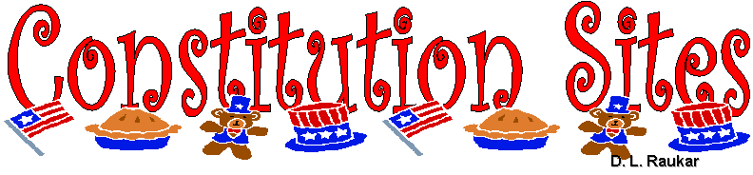
Scholastic Constitution Game: This great game will help you to get to know the constitution better.
Jeopardy Games and Constitution : Free jeopardy games for the constitution.
Save the Bill of Rights Game: Check this one out, too.
Constitution Clip art: Classroom clip art has some good clip art resources
CyberSleuth for Kids Founding Fathers Clip art: Cybersleuth has good information, too.
CyberSleuth for Kids American Revolution Clip art
Academic Kids Encyclopedia
http://www.academickids.com/encyclopedia/index.php/Continental_congress
The Constitution Emory Law School: This law school lists the constitution out click by click

